Contents

Find all the information about each product. 1

Find the product price which are between 400 to 800 4

Find the product price which are not between 400 to 600 5

List the four product which are greater than 500 in price 9

Find the product name and product material of each products 9

Find the product with a row id of 10 11

Find only the product name and product material 12

Find all products which contain the value of soft in product material 13

Find products which contain product color indigo  and product price 492.00 14

Delete the products which product price value are 28 15

# Find all the information about each product.

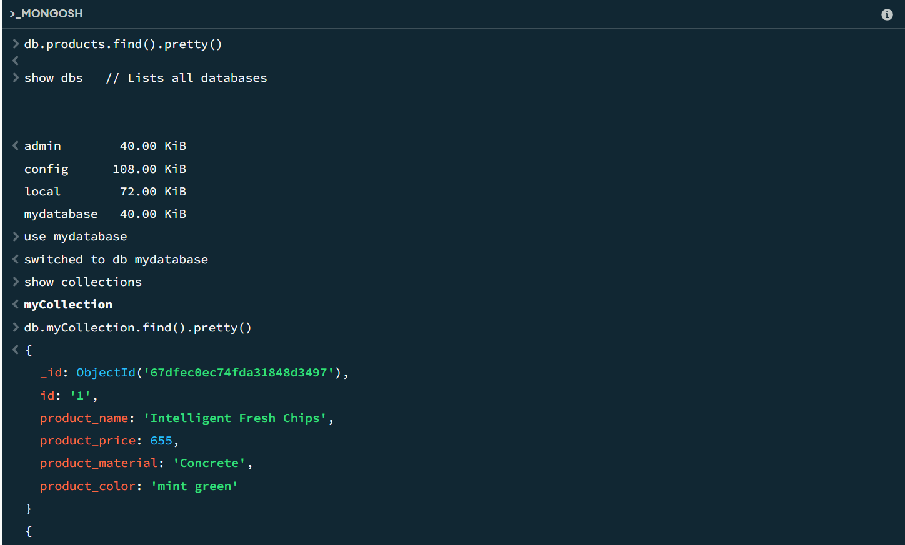

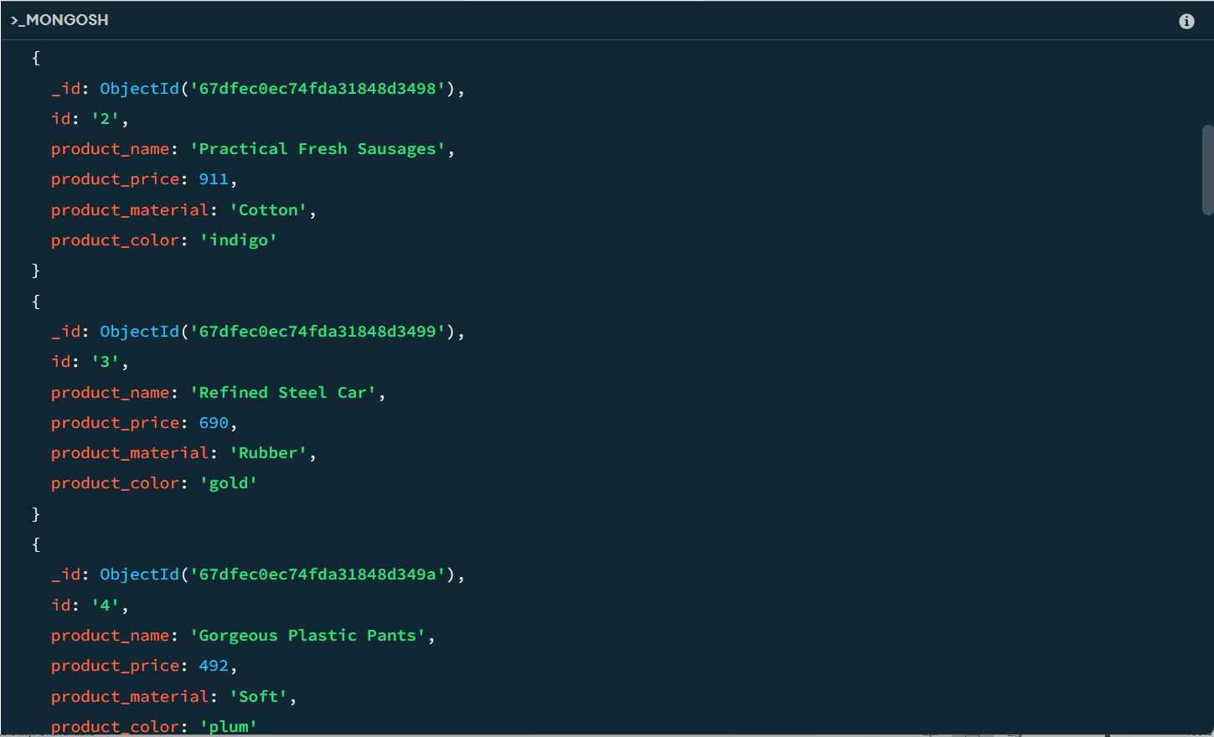

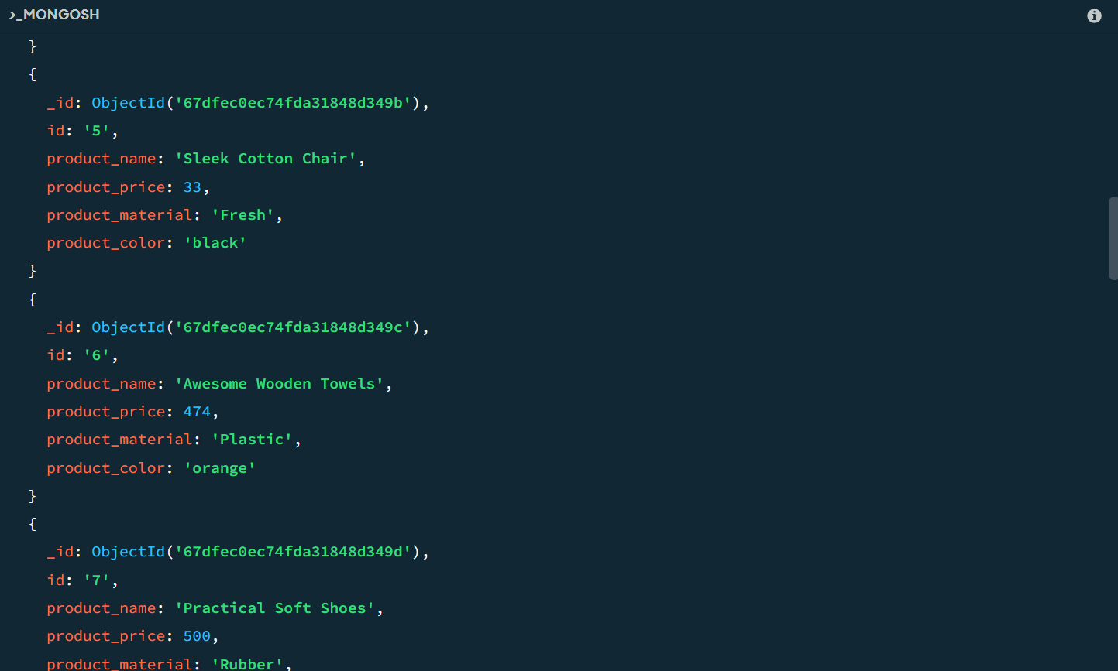

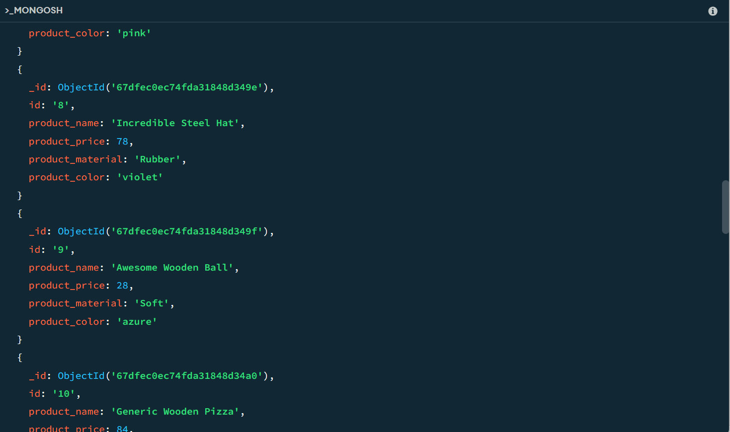

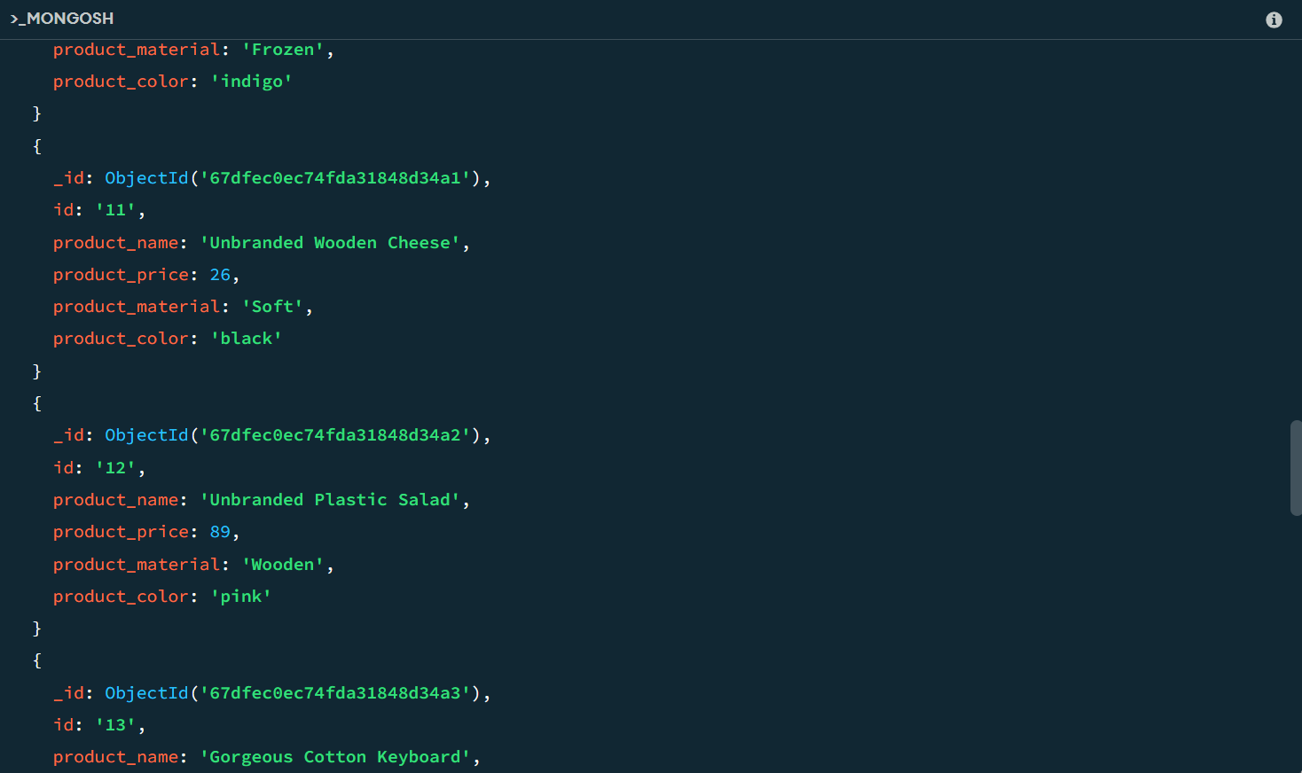

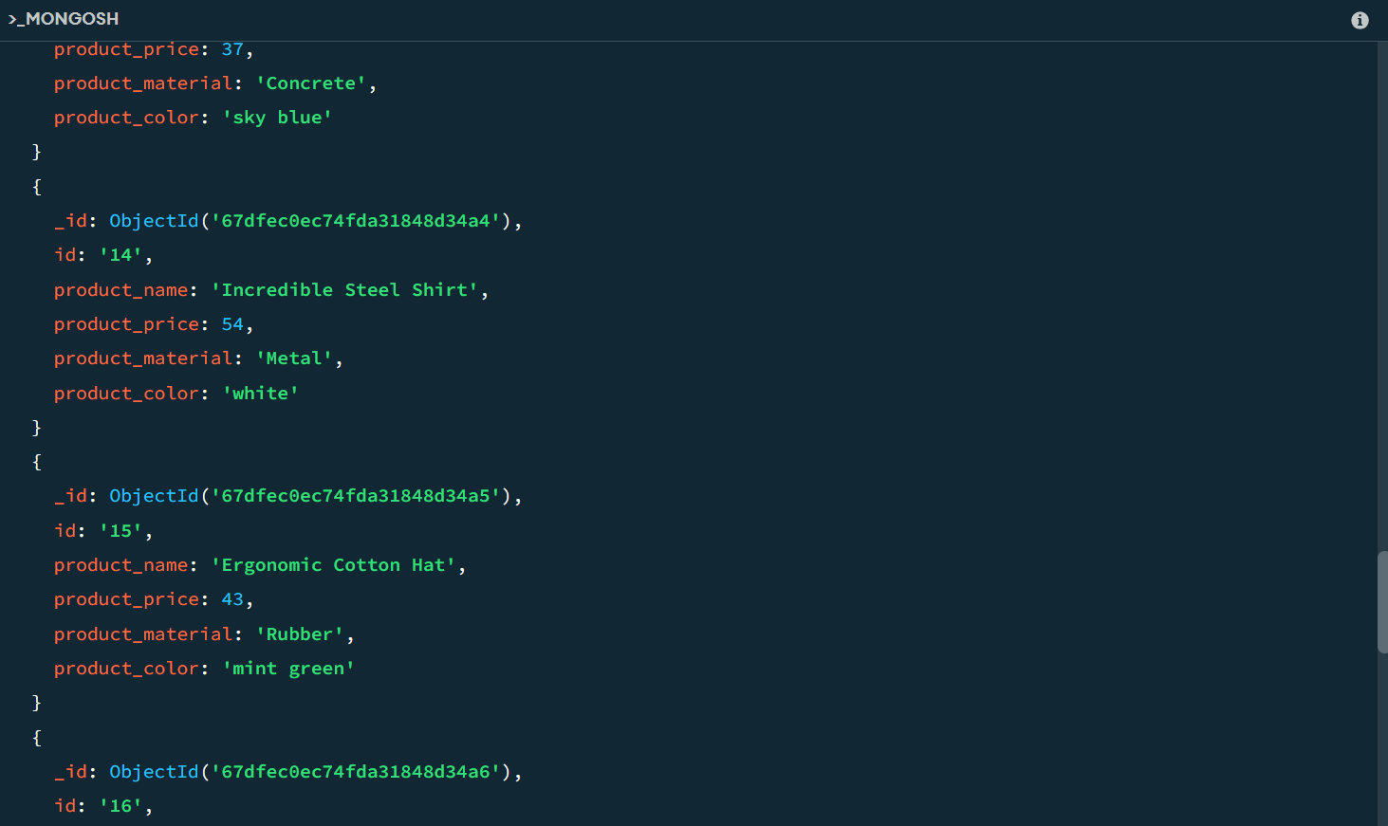

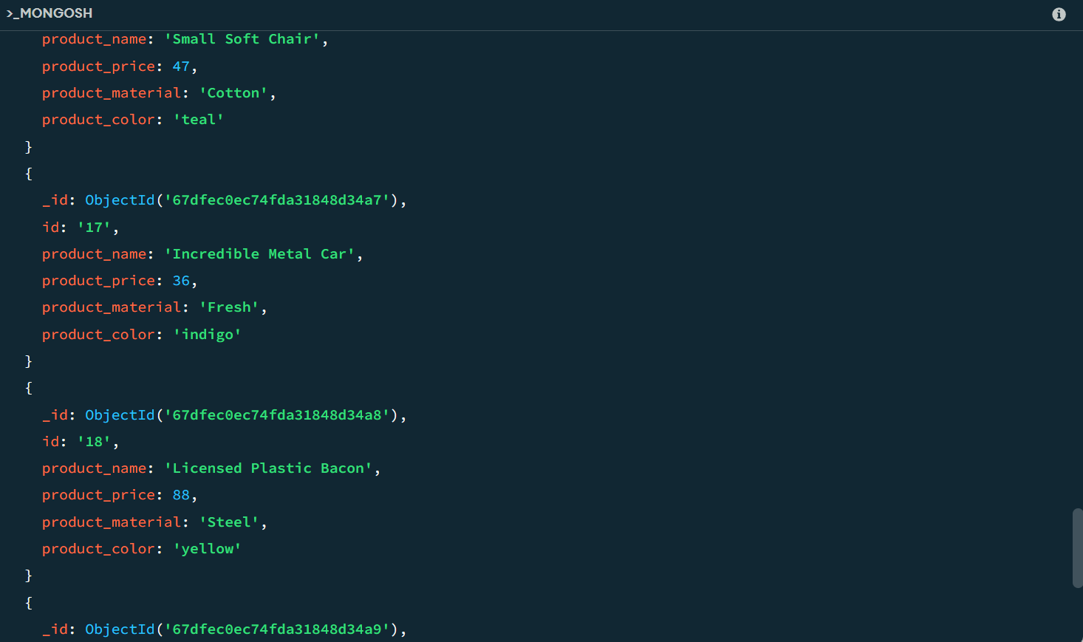

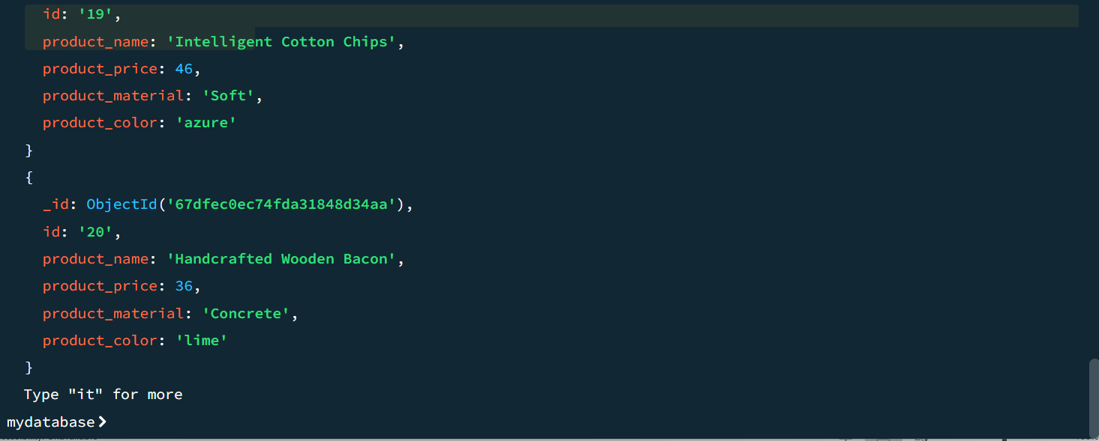

## Find the product price which are between 400 to 800

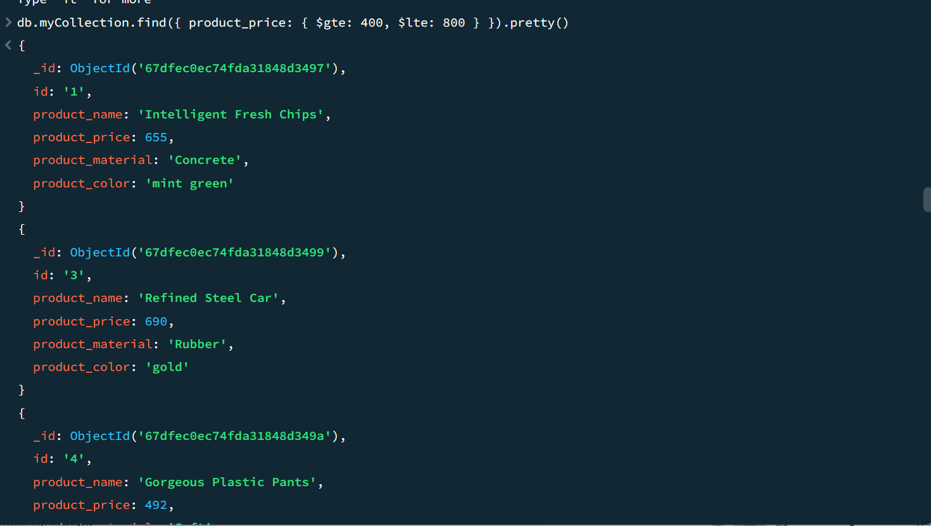

## Find the product price which are not between 400 to 600

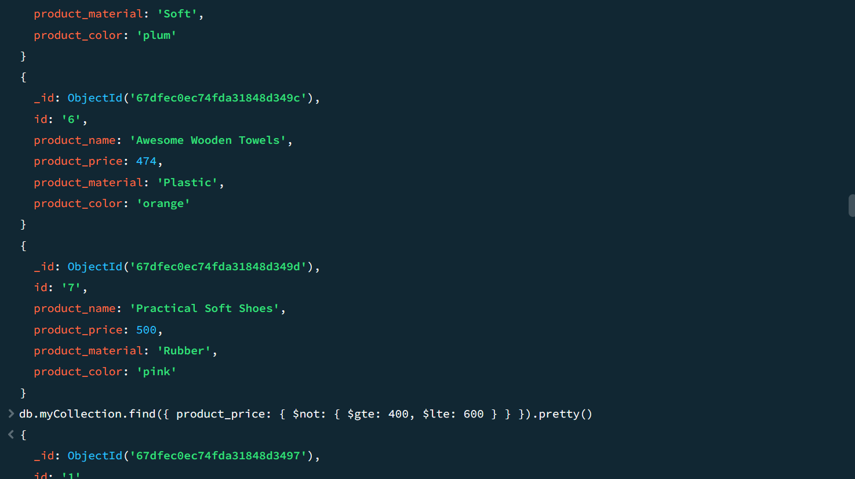

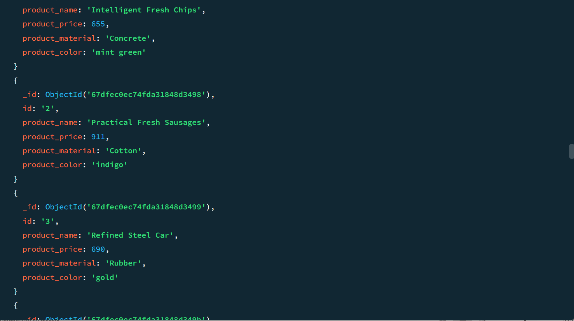

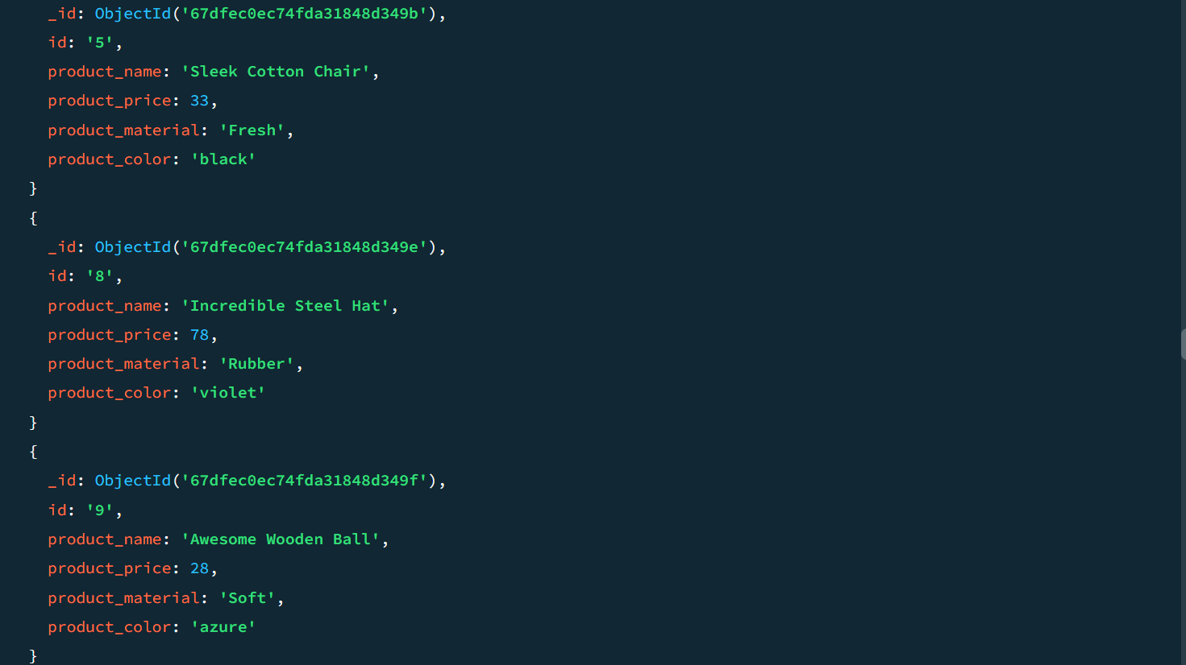

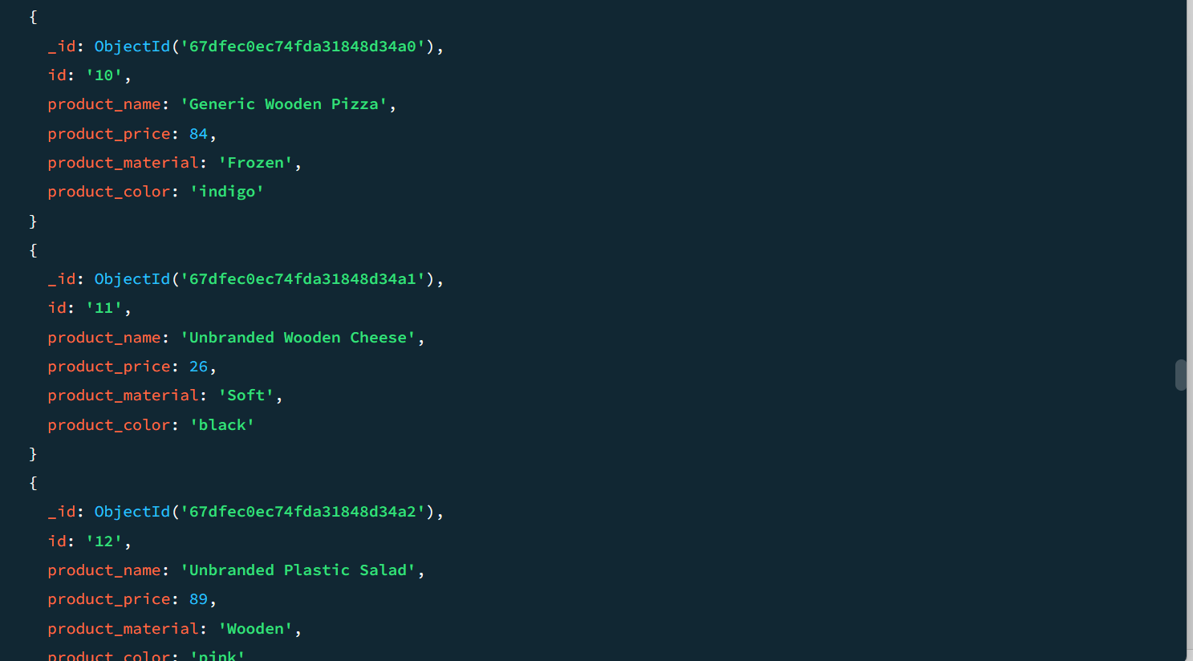

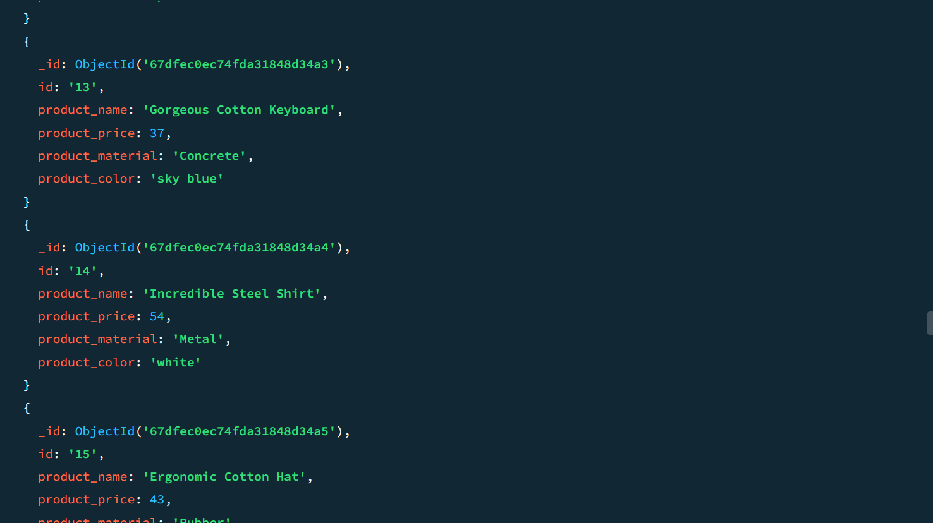

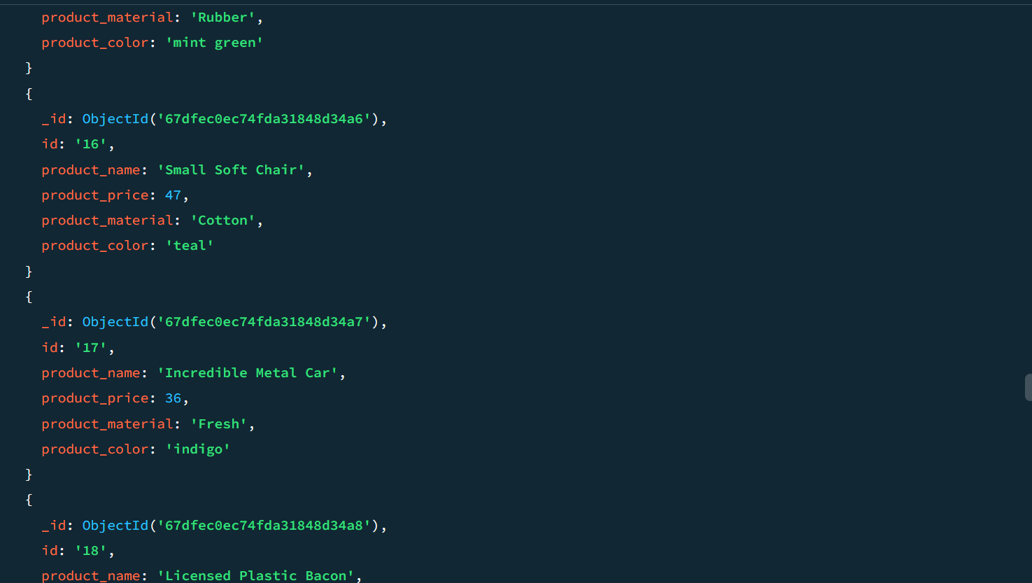

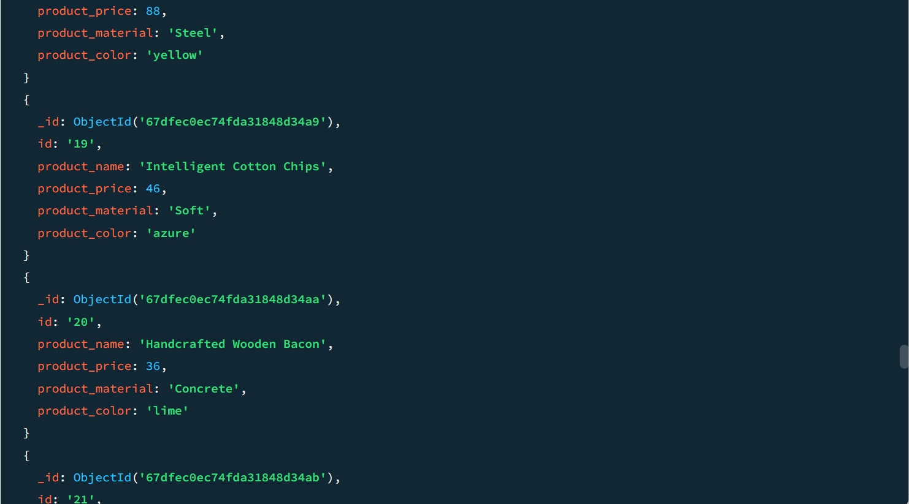

## List the four product which are greater than 500 in price

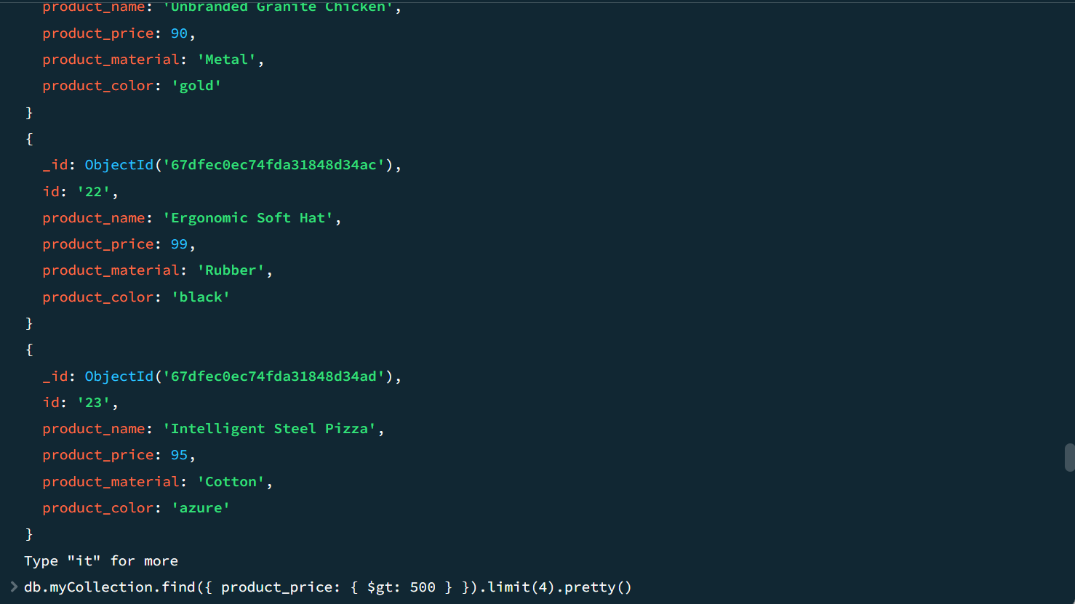

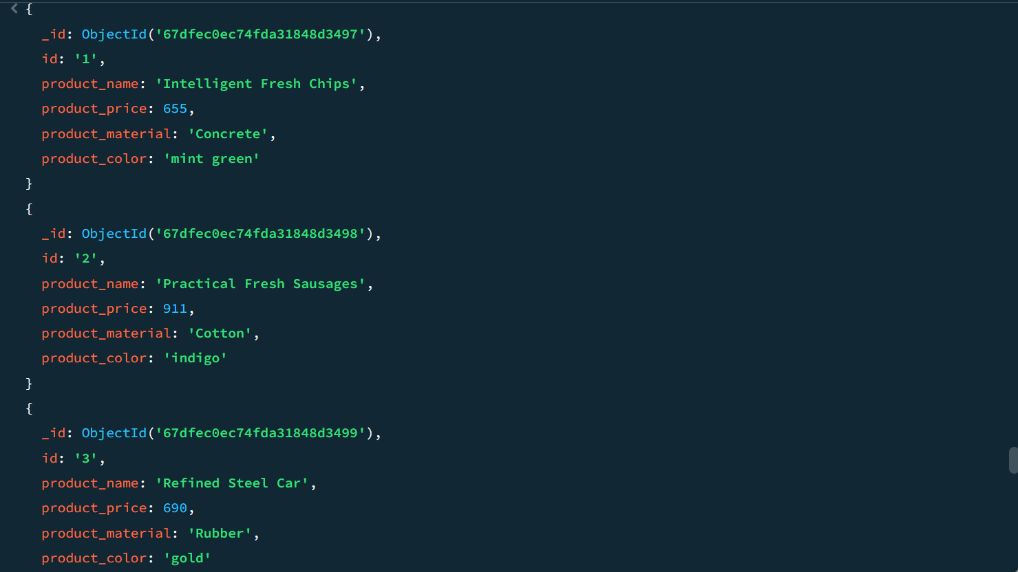

## Find the product name and product material of each product

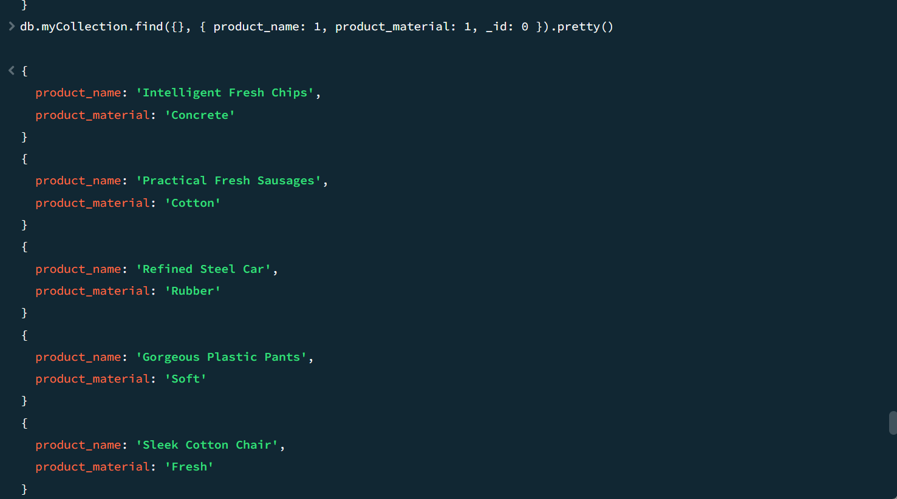

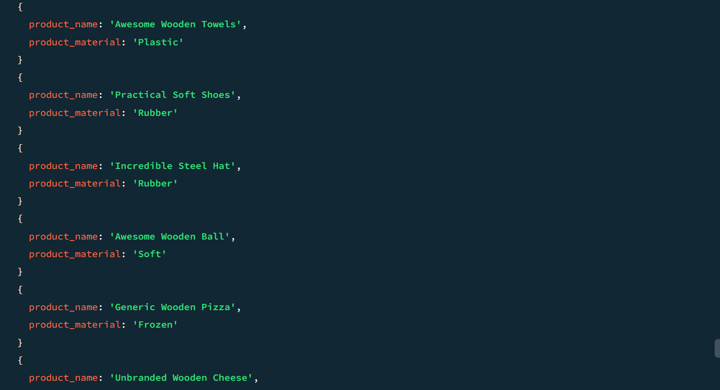

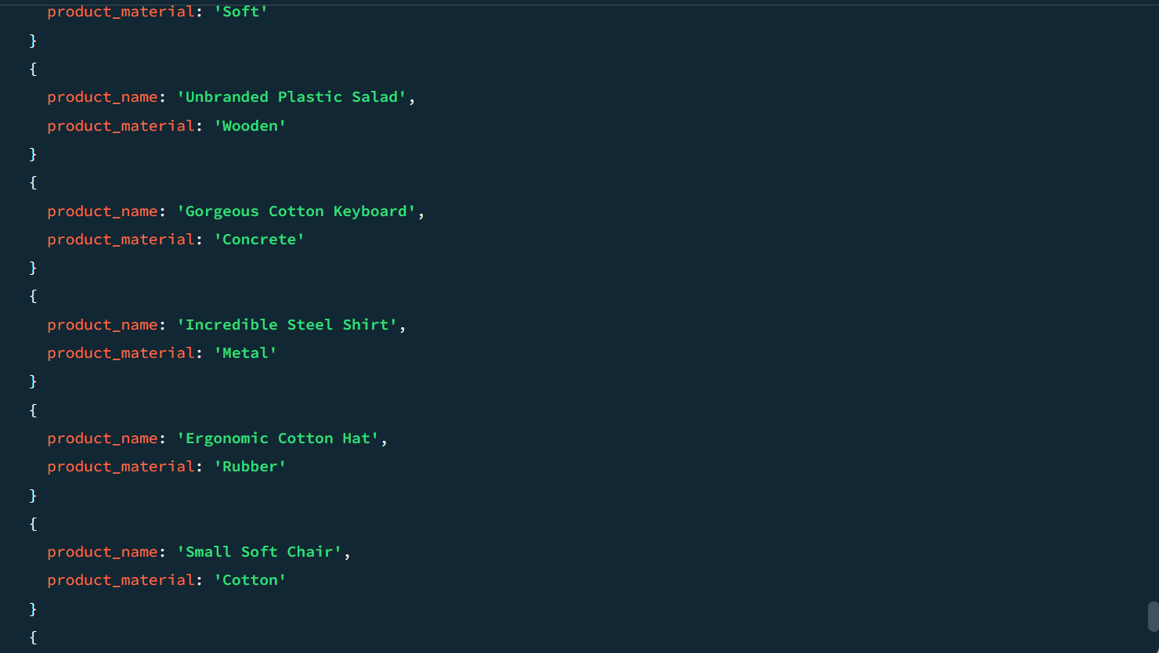

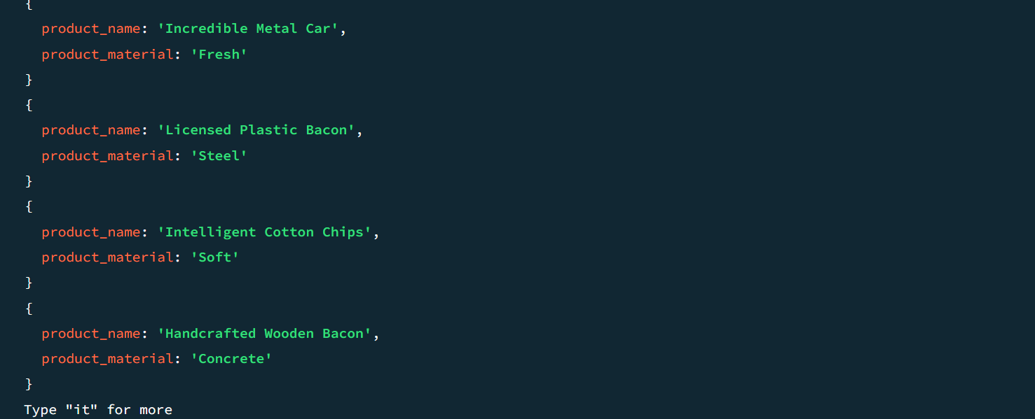

## Find the product with a row id of 10

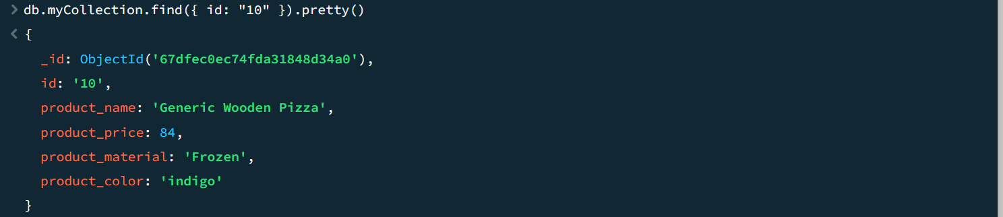

## Find only the product name and product material

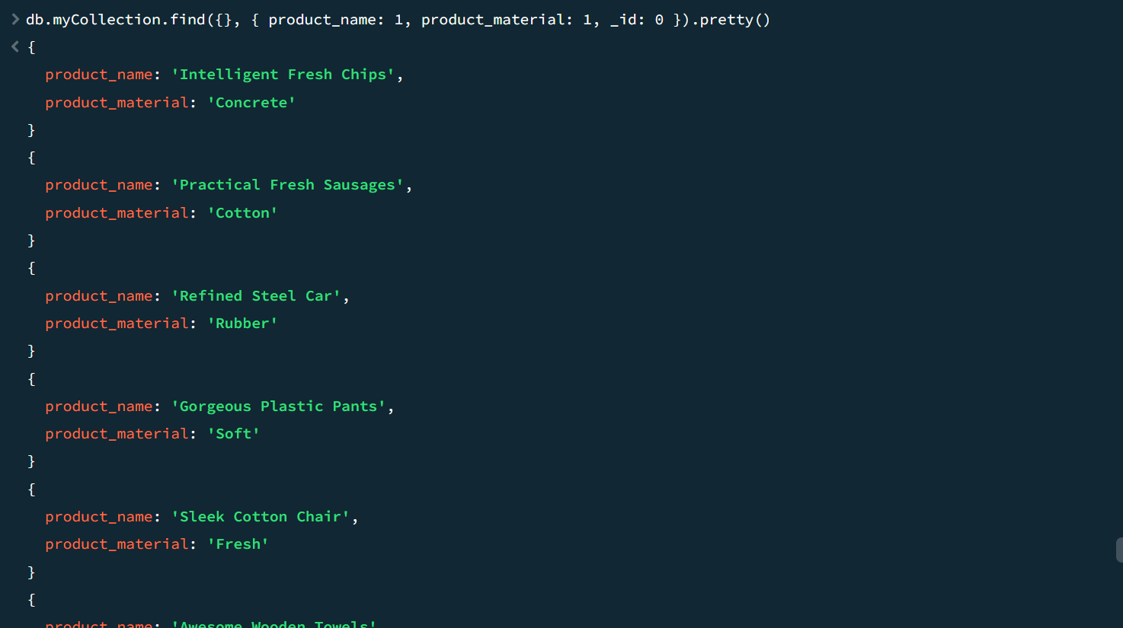

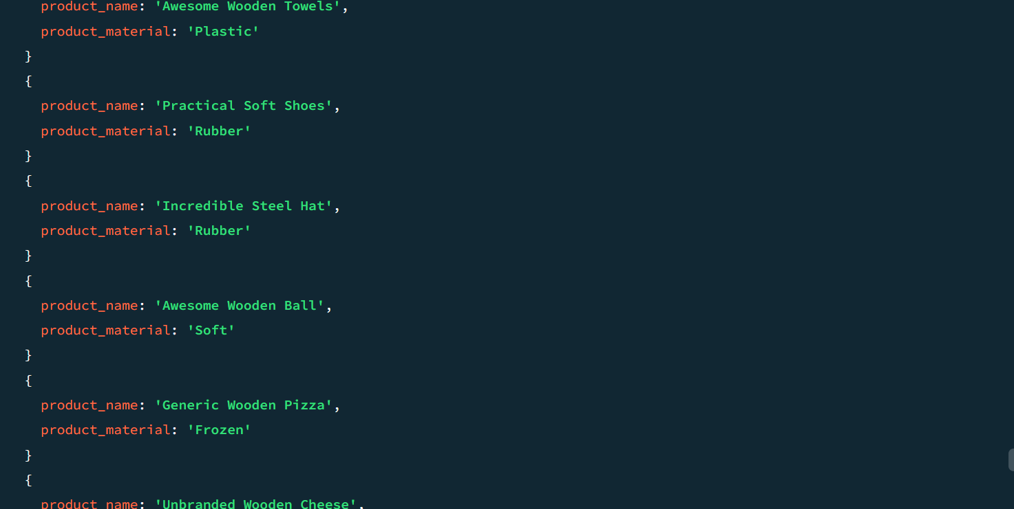

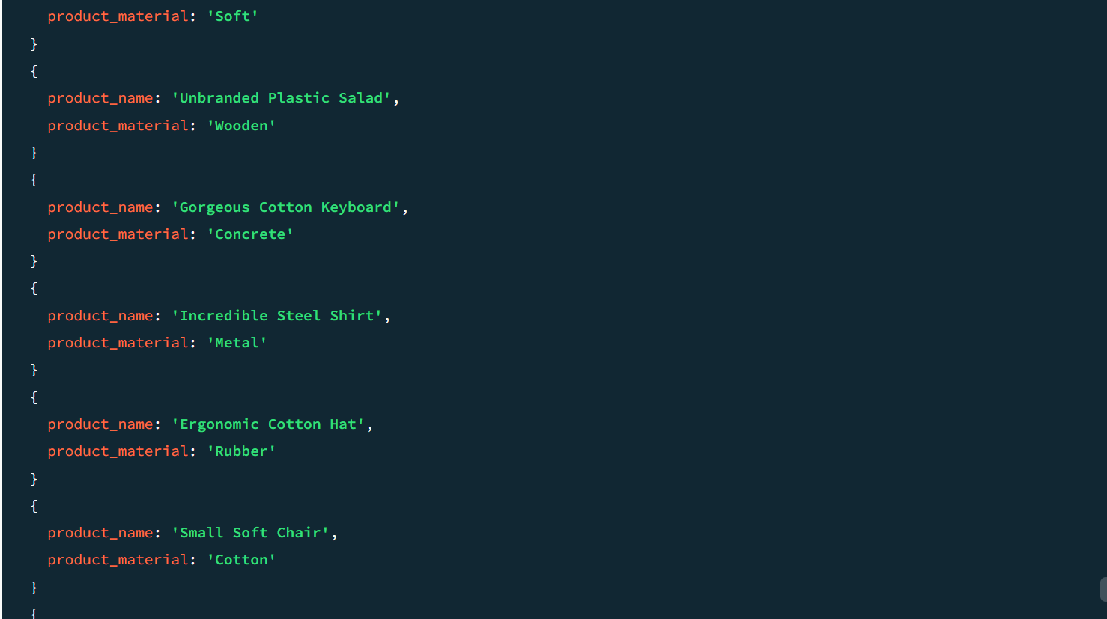

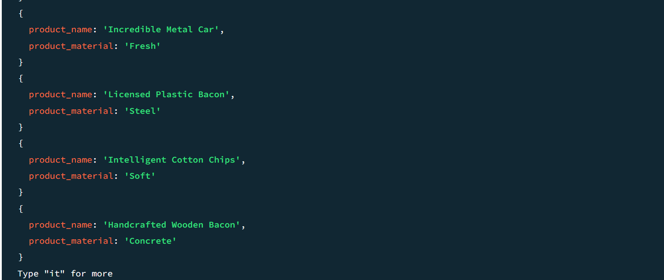

## Find all products which contain the value of soft in product material

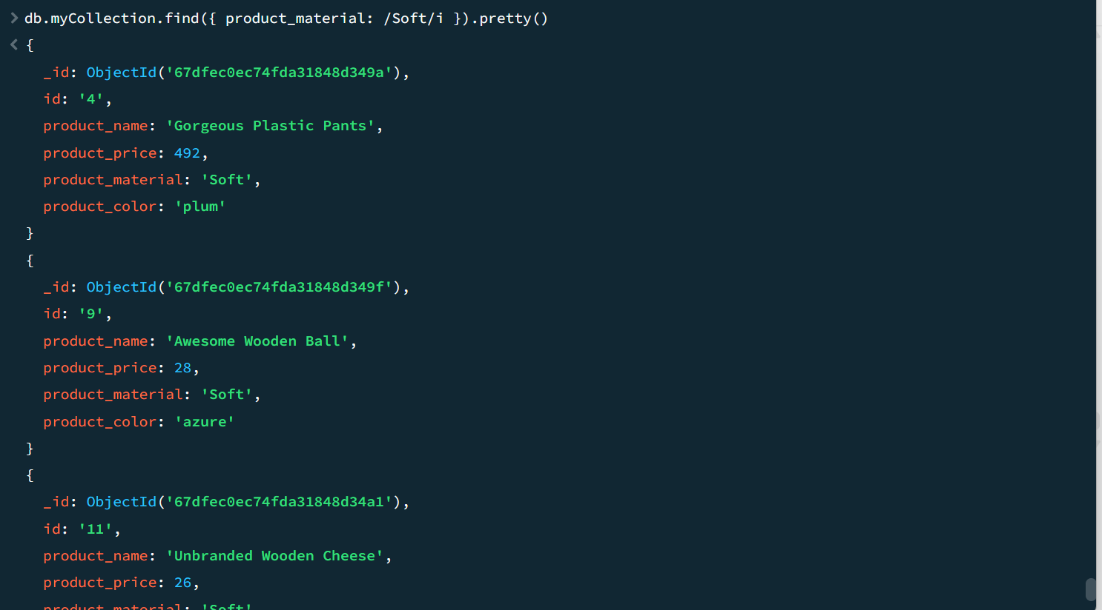

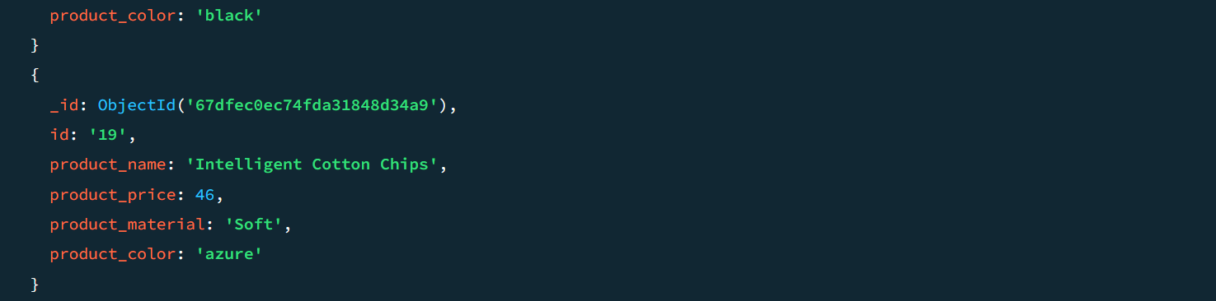

## Find products which contain product colou

## r indigo and product price 492.00

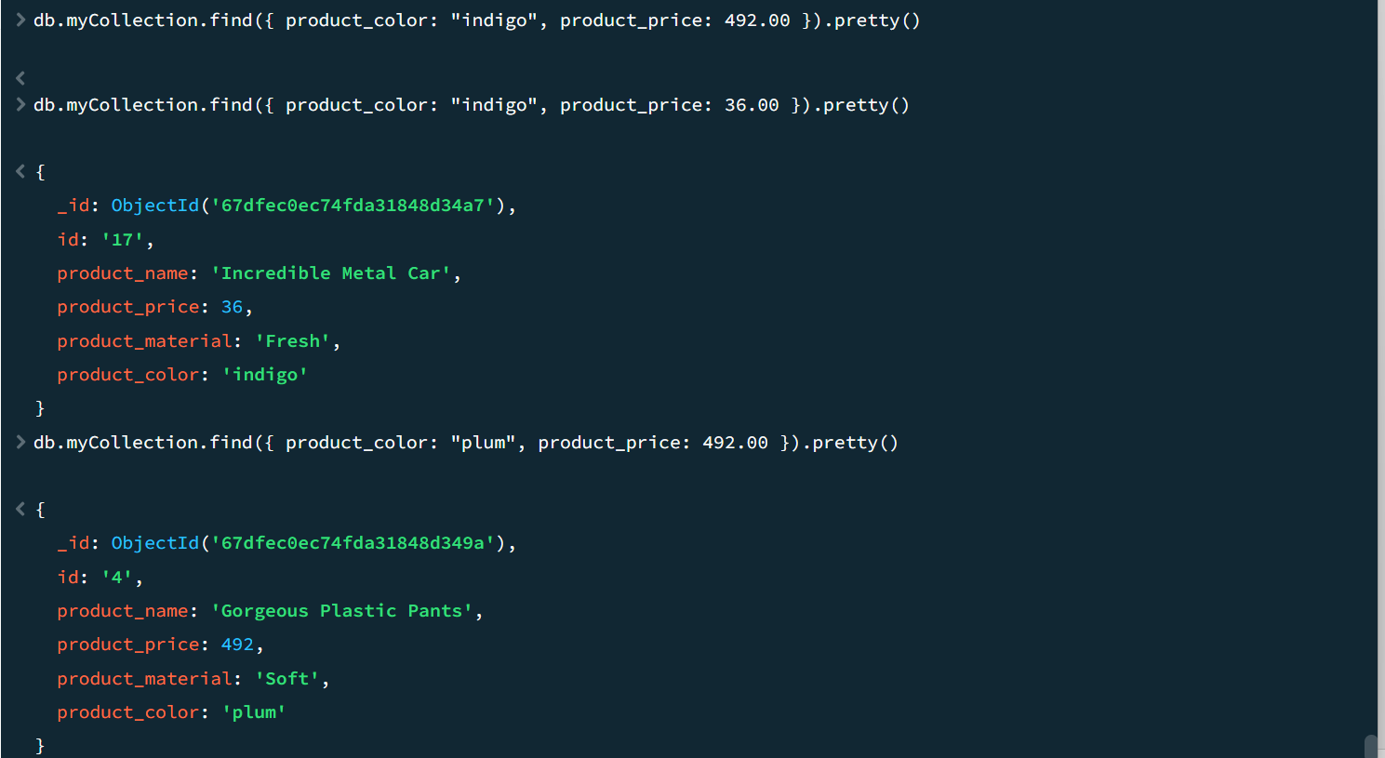

## Delete the products which product price value are 28

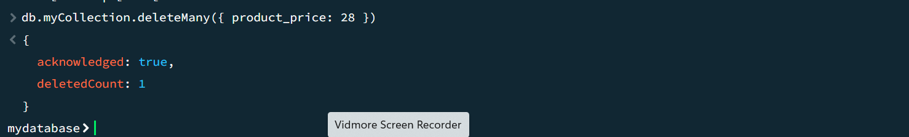

# Write a program for jdbc connectivity and insert the below the data.

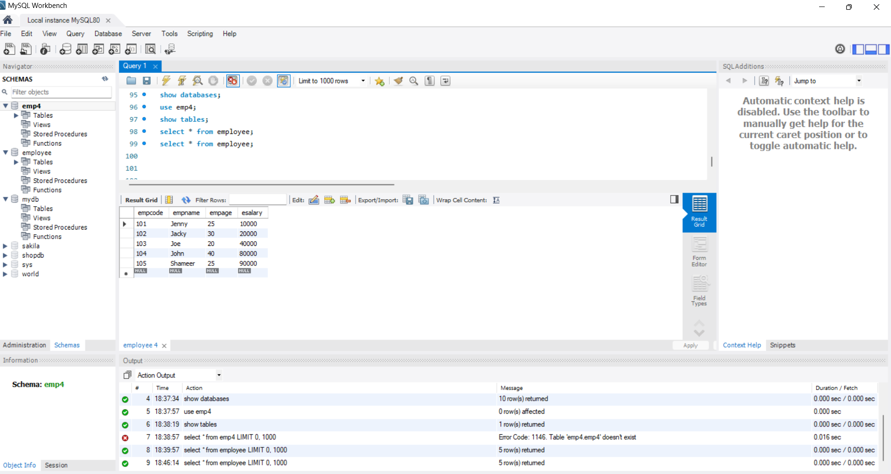

Create a table Empl to store employee details as shown below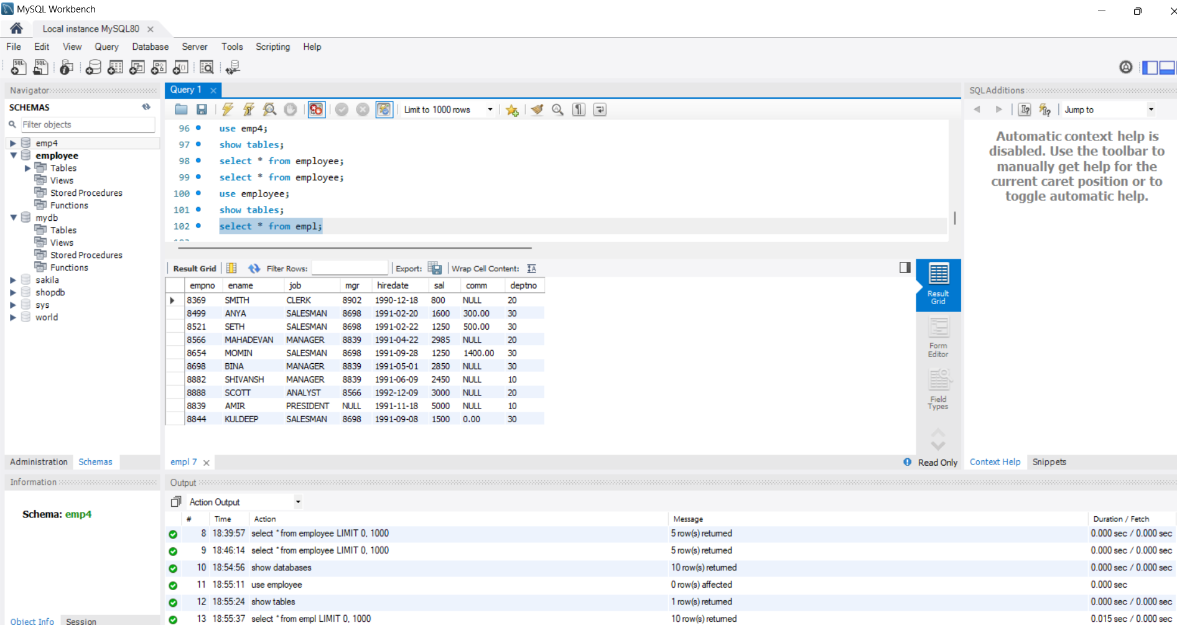

Write a query to display ename and sal from Employees whose salaries are greater than or equal to 2200.

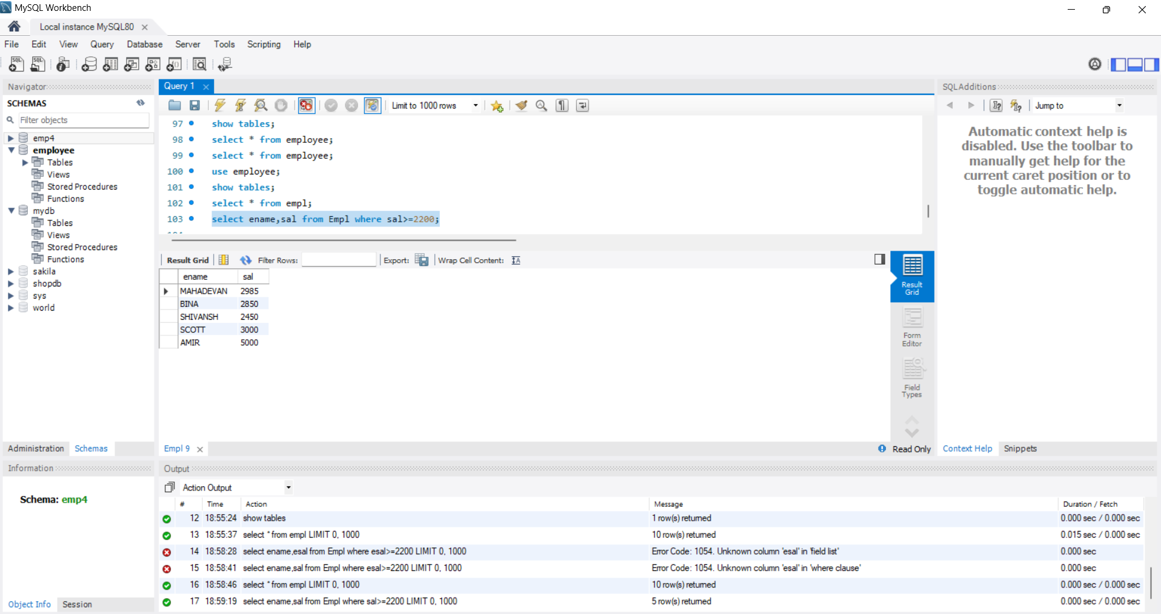

## Write a query to display details of employee who are not getting commission?

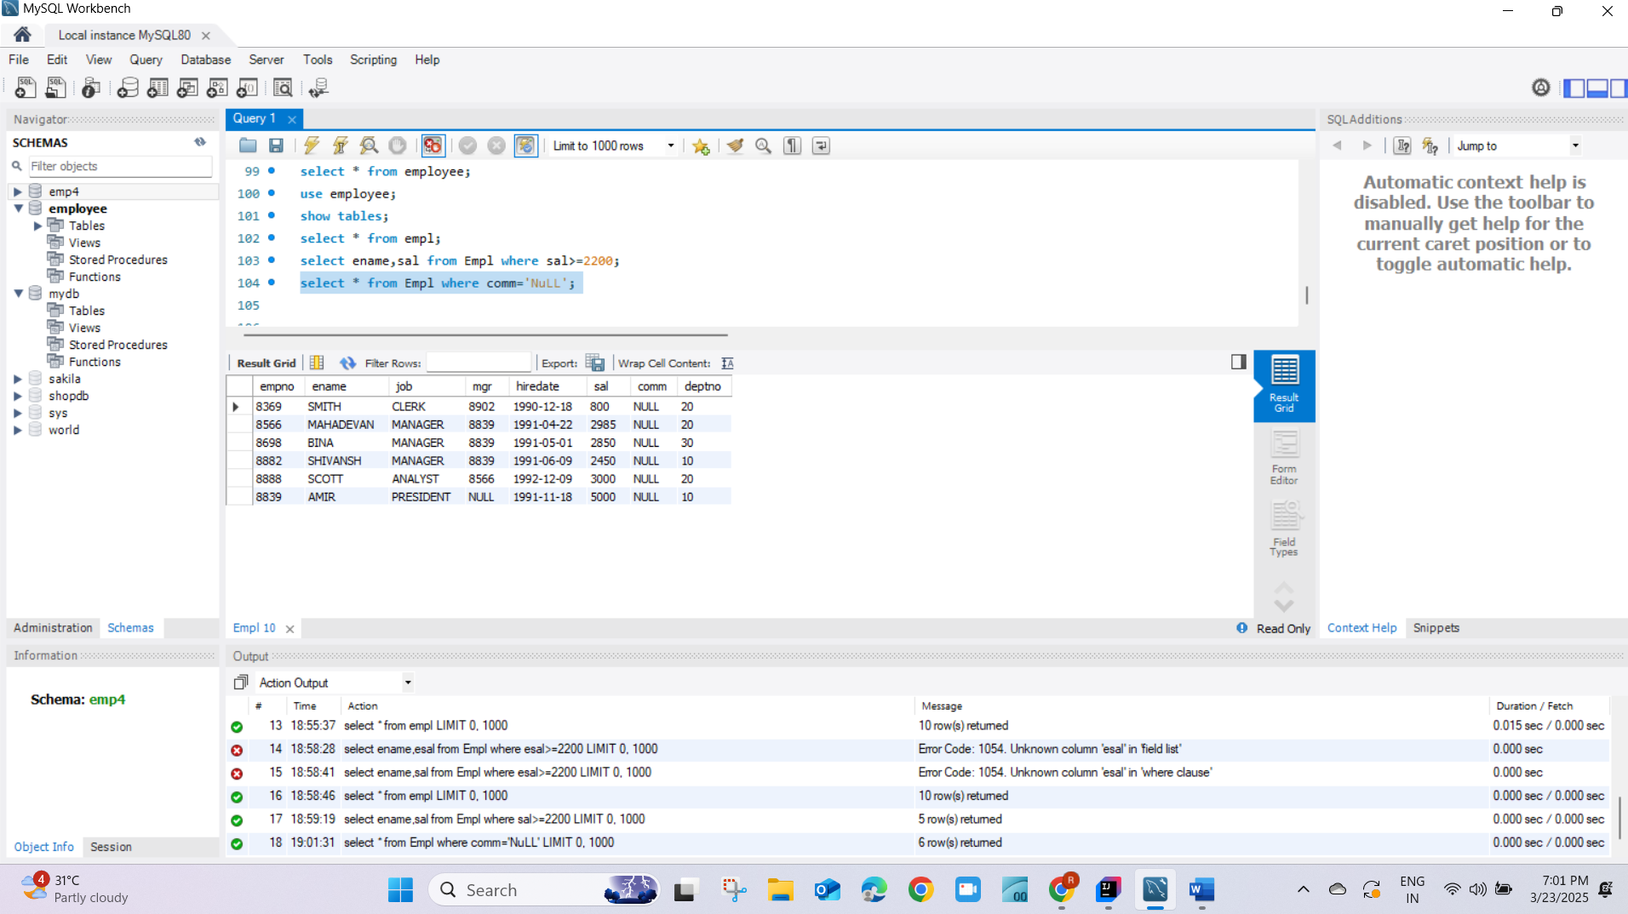

## Write a query to display employee name and salary of those employees who don’t have their salary in the range 2500 to 4000

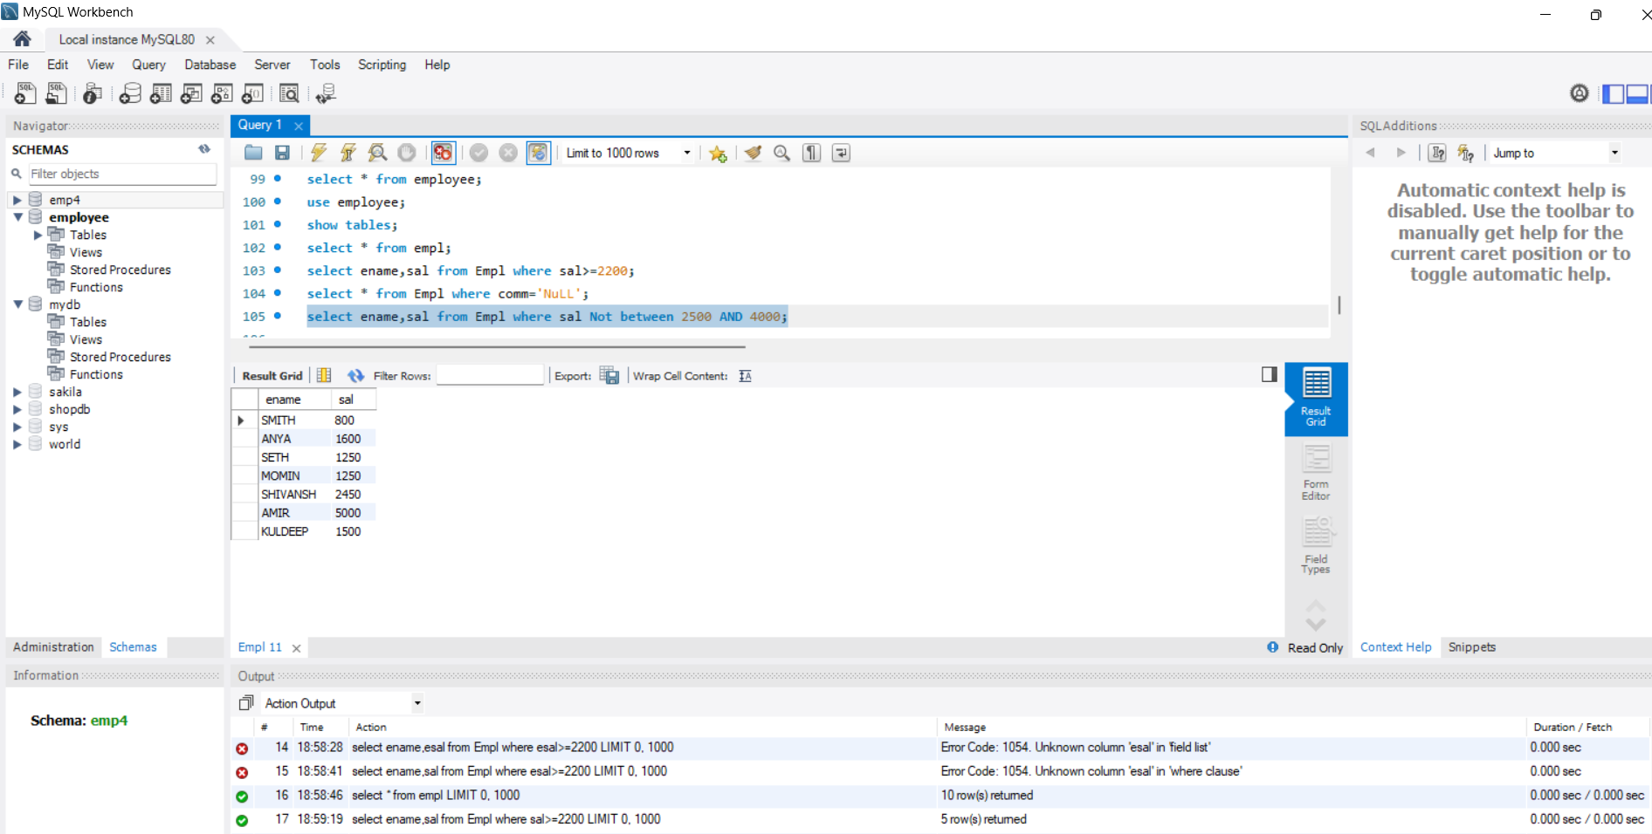

## Write a query to display the name,job title and salary of employees who don’t have a manager

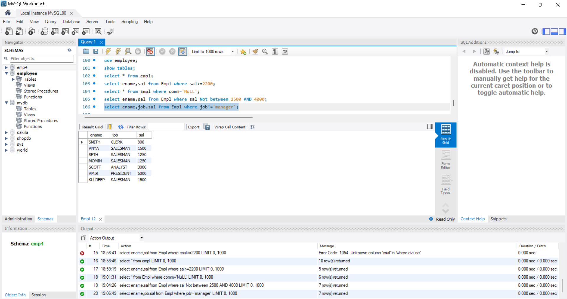

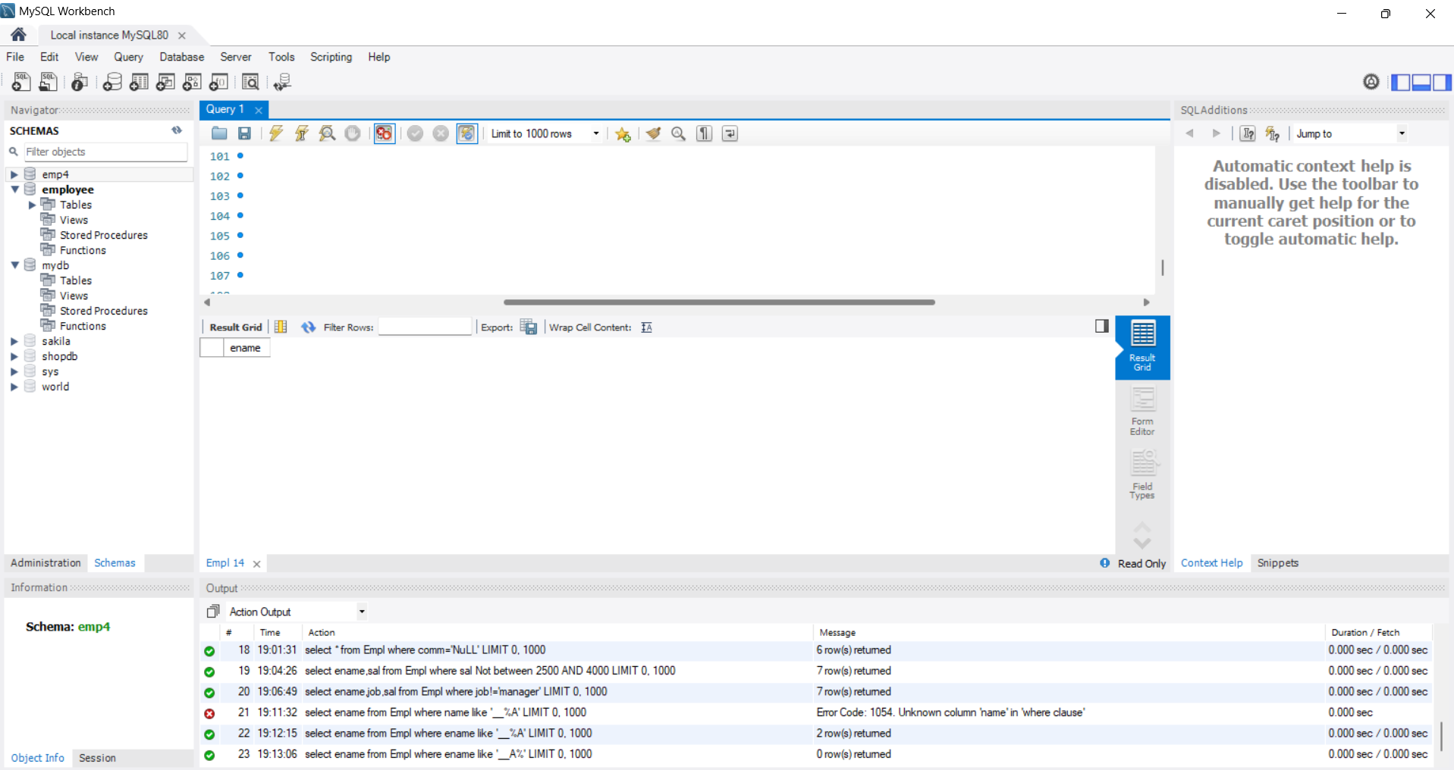

## Write a query to display the name of an employee whose name contains “A” as third Alphabet.

Write a query to display the name of an employee whose name contains “T” as the last Alphabet.